

Member Handbook

CHARTERED NOV 08, 1991

DISTRICT 6970

ROTARIANS ARE PROFESSIONAL MEN AND WOMEN WHO,

AS VOLUNTEERS, WORK TO IMPROVE THE QUALITY OF LIFE

IN THEIR HOMES, THEIR COMMUNITIES, AND THEIR WORLD.

MEMBERSHIP IS NON-POLITICAL, NON-RELIGIOUS, AND OPEN TO ALL CULTURES, RACES, AND CREEDS. FLAGLER BEACH IS ONE OF

OVER 35,000 CLUBS AROUND THE WORLD.

**Table of Contents**

Four Way Test, Avenues of Service & Attenance page 3

Rotary Club of Flagler Beach Strategic Plan page 4

Current Projects of Flagler Beach page 5

Officers of Flagler Beach, District 6970 & Board Meetings page 6

Past Presidents-Flagler Beach………………… page 7

Member Obligations……………………………… page 7

How to Learn More about Rotary…………………….. page 8

**The Definition of Rotary**

“Rotary is an organization of business and professional persons united worldwide who provide humanitarian service, encourage high ethical standards in all vocations and help build peace and goodwill in the world.”

**The Mission of Rotary**

***Rotary’s***primary mission is service. In the community, in the workplace, and throughout the world.

***Rotarians*** build goodwill and peace, undertake humanitarian endeavors, and encourage high ethical standards in all vocations, demonstrated by their actions.

***Rotarians*** develop community service projects that address many of today’s most critical issues, such as children at risk, poverty and hunger, the environment, literacy, and water.

***Rotary’s Mottos***: *“Service Above Self” & “One Profits Most Who Serve Best”*

**The Rotary Foundation**

The Rotary Foundation is our charity, a not-for profit corporation that promotes world understanding through international humanitarian service programs and educational and cultural exchanges. It is supported solely by voluntary contributions from Rotarians and others who share its vision of a better world.

**The Object of Rotary:** to encourage and foster the ideal of service as a basis of worthy enterprise and in particular, to encourage and foster:

* The development of acquaintanceship as an opportunity of service;
* High ethical standards in business and professions; the recognition of the worthiness of all useful
* Occupations and the dignifying of each Rotarian’s occupation as an opportunity to serve society;
* The application of the ideal of service in each Rotarian’s personal, business, and community life; and
* The advancement of international understanding, goodwill, and peace through a world fellowship of
* business and professional persons united in the ideal of service.

**The Four-Way Test**

The following 24-word test created in 1932 by Rotarian Herbert J. Taylor for employees to follow in their business and professional lives became the guide for sales, production, advertising, and all relations with dealers and customers. It was adopted by Rotary in 1943.

“Of the things we think, say or do:

1. Is it the **TRUTH**?
2. Is it **FAIR** to all concerned?
3. Will it build **GOODWILL** and **BETTER FRIENDSHIPS**?
4. Will it be **BENEFICIAL** to all concerned?

The Rotary Club of Flagler Beach does a Five-Way Test and adds:

5. Have fun in all we do!

**SERVICE**

Five Avenues of Service

Based on the Object of Rotary, the Five Avenues of Service are Rotary’s philosophical cornerstone and the foundation on which club activity is based:

• Club Service focuses on strengthening fellowship and ensuring the effective functioning of the Club.

• Vocational Service encourages Rotarians to serve others through their vocations and to practice high ethical standards.

• Community Service covers the projects and activities the Club undertakes to improve life in its community.

• International Service encompasses actions taken to expand Rotary’s humanitarian reach around the globe and to promote world understanding and peace.

• New Generations Service recognizes the positive change implemented by youth and young adults through leadership development activities, service projects, and exchange programs.

Obligations of Service

Rotary is an organization of members, committed to service:

**·**To participate in Rotary projects.

**·**To serve willingly on one or more committees.

**·**To attend Rotary District meetings such as Assemblies, Conferences, Seminars, etc., when possible.

Attendance

Fun and fellowship are the hallmarks of the Flagler Beach meetings. All members are encouraged to attend weekly. In the event you cannot attend a meeting, a makeup meeting can be attended at any Rotary club in the local area and the world at large. Flagler Beach hopes you make two meetings a month, or service projects, socials, fundraisers and more.

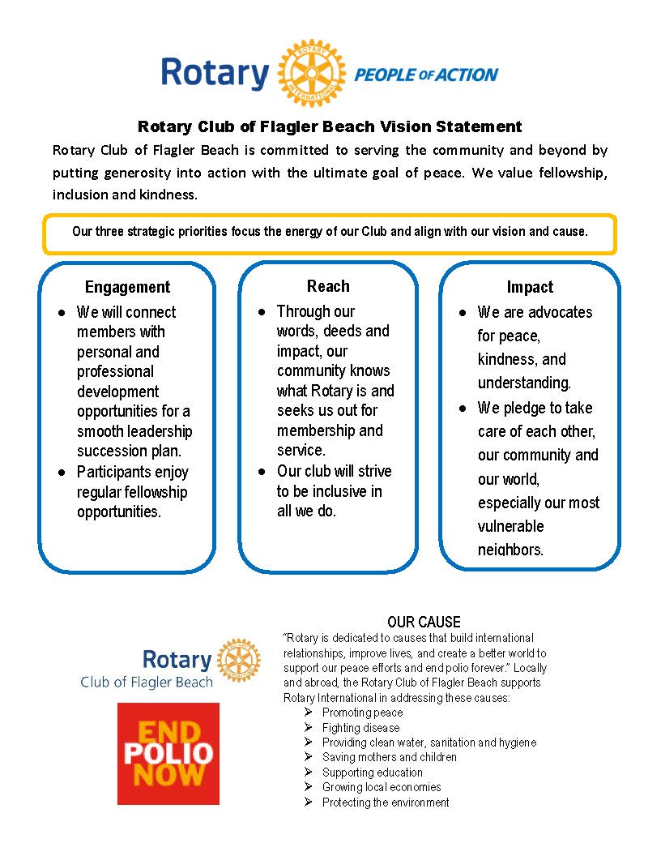

**Current Service Projects and Fundraisers**

**The Rotary Club of Flagler Beach**

**Project Share** supports members of the Pierson area migrant community with food and nutrition needs, clothing, a Christmas experience, and MORE.

**Race the Runways**  A 5K held on the runways of the Flagler Executive Airport.

**Flagler Flag Project**  For $50, the club will set up an American flag in a sponsor's yard on 7 holidays..

**Golf Ball Drop** A fun twist on a FUN-draiser. Our club sells tickets and golf balls are dropped from a helicopter at the local airport. Winners are based on proximity to the flag.

**Polio Eradication** – Rotary has played a lead role in the world wide eradication of Polio and continues to do so. In conjunction with the World Health Organization and in partnership with the Gates Foundation, it is a major emphasis of Flagler Beach and Rotary International.

**Youth Initiatives**  Interact Club (Rotary's outreach with Flagler Palm Coast High School); Early Act Club (Rotary's outreach to 3rd graders at Old King’s Elementary School): RYLA (Rotary Youth Leadership Awards; Rotary Youth Exchange, from time to time we host an exchange student; Scholarships, on a yearly basis we use some of our funds to support students in need to advance their education.

**Other Projects As They Present Themselves** Examples: mailboxes in an area of Bunnell underserved by the USPS, Emergency Response Trailer for City of Flagler Beach, sun protection hats for migrant workers.

AND MORE…

**2022-2023 OFFICERS AND COMMITTEE CHAIRPERSONS**

President Sheila Pillath

President Elect Roy Sieger

Immediate Past Pres Alicia Vincent

Secretary Andrea Verdi

Treasurer Henry Estrada

Assist. Treas. & Director Deborah Horst

Bunnell Satellite Chair & Director Nealon Joseph

Public Relations Chair Pam Birtolo

Membership Chair & Director Debby Meyer

Foundation Chair Art MacQueen

Interact Chair & Director Sandra McDermott

At-large Directors Mary Elizabeth Mills

Roy Sieger

Robert Snyder Mickey Ulmer

**2022-2023 DISTRICT #6970**

District Governor: Jeffrey Michelman

Rotary Club of Jacksonville Beach

**2022-23 ROTARY INTERNATIONAL PRESIDENT**

Jennifer Jones- Rotary Club of Windsor - Roseland, Ontario

2022-23 Rotary Theme: *Imagine Rotary*

**BOARD MEETINGS**

Third Wednesday at 5:30pm at

Flagler County Executive Airport

All members are welcome and encouraged to participate.

**BUNNELL SATTELITE CLUB**

Meets the 2nd and 4th Tuesdays, 5:30pm, Grand Reserve



**PAST PRESIDENTS OF THE ROTARY CLUB OF FLAGLER BEACH AND MORE**

1990-91 Charles Bush Charter President

1991-92 Peggy Frazarand 2007-08 Pat McCallister

1992-93 Robert Tate 2008-09 Jeanne Passalaqua

1993-94 Charlie Helm 2009-10 Tom Gillin

1994-95 Charles Meyer 2010-11 Donna Tofal

1995-96 Keith Martino 2011-12 Tim O'Donnell

1996-97 Robert Clark 2012-13 Sandra McDermott

1997-98 Connie Boyle 2013-14 Tim O'Donnell

1998-00 Ken Eaton 2014-15 Kim Carney

2000-01 Jodie Bevel 2015-16 Kathy Somers

2001-02 Joyce Edson 2016-17 Cindy Dalecki

2002-03 Tom Hury 2017-18 Amanda Bailey

2003-04 Joy McGrew 2018-19 Sean Palmer

2004-05 Lea Stokes 2019-20 Roy Sieger

2005-06 Bonnie Scott 2020-21 Roseanne Stocker

2006-07 Judi Stetson 2021-22 Alicia Vincent

Other Past Presidents and Rotary Officers

2004-05 Art MacQueen, Rotary Club of Daytona Beach West

2011-12 John Emery Rotary Club of Jacksonville Oceanside

2013-14 Art MacQueen, Governor District 6970

2022-23 Mickey Ulmer, District Governor Nominee District 6970

**Member Obligations**

Financial Responsibilities

One Time Initiation/Application Fee $50.00

Dues Paid Quarterly (approximately) $160.00

*(includes District & Rotary International Dues, Rotary Magazine & weekly breakfast fee)*

Guest charge for breakfast $10.00

Other fees from time to time are voted on and billed for the betterment of the club, projects or social events. At no time to date have they met or exceeded a single quarter total in an entire year. We encourage our members to support the Rotary Foundation with a donation of $100/year.



We are 50+ strong and growing!

Join us and make a difference!

The bell rings at 8:00AM Thursday mornings at Santa Maria del Mar Catholic Church, O'Flaherty Hall, 915 N. Central Ave.

Rotarians identify a problem, join leaders and take action!

For additional information, please speak with current club members and visit the following websites.

Rotary International <https://www.rotary.org>

District 6970 <https://rotarydistrict6970.org/>

Rotary Club Flagler Beach <https://www.flaglerbeachrotary.org/>